AWS RDS Assignment

1. Create MariaDB on EC2
- Launch an Amazon Linux EC2 instance.
- Install MariaDB: sudo dnf install mariadb105-server -y
- Start and enable service: sudo systemctl enable --now mariadb
- Login: mysql -u root
- Create database 'company' and table 'employees'.
- Insert 5 dummy records.
- Screenshot: MariaDB running and SELECT * FROM employees;
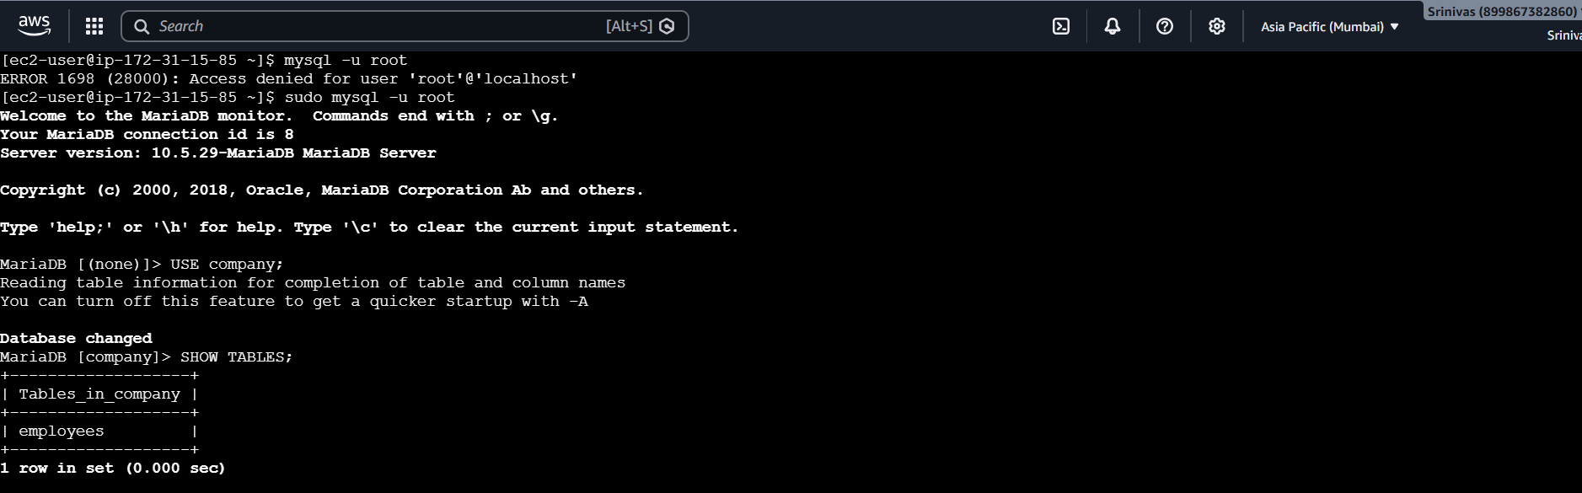
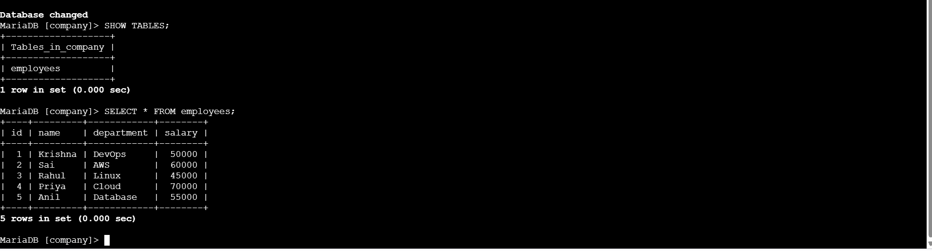

2. Take Backup on EC2
- Export database:
- mysqldump -u root company > company_backup.sql
- Verify: ls -lh company_backup.sql
- Screenshot: backup file created.
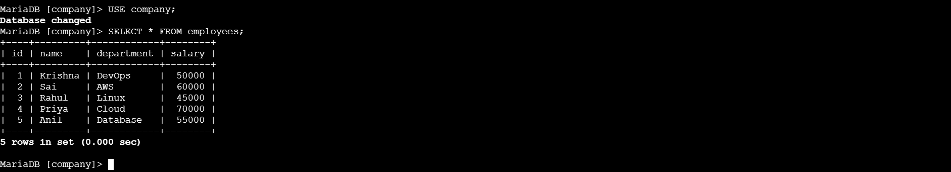
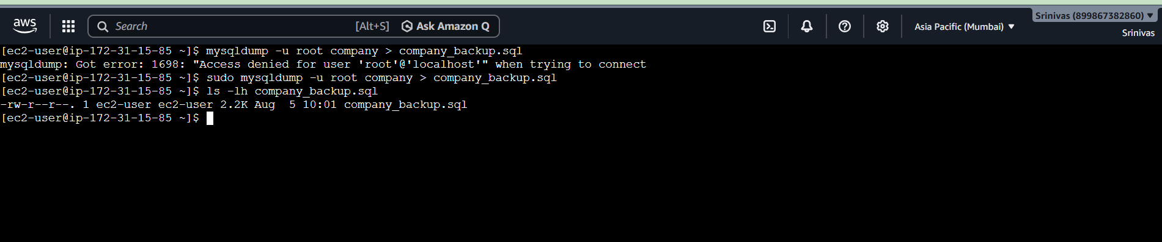

3. Launch MariaDB RDS
- Create MariaDB RDS instance.
- Configure master username/password.
- Wait until status becomes Available.
- Screenshot: RDS Available.
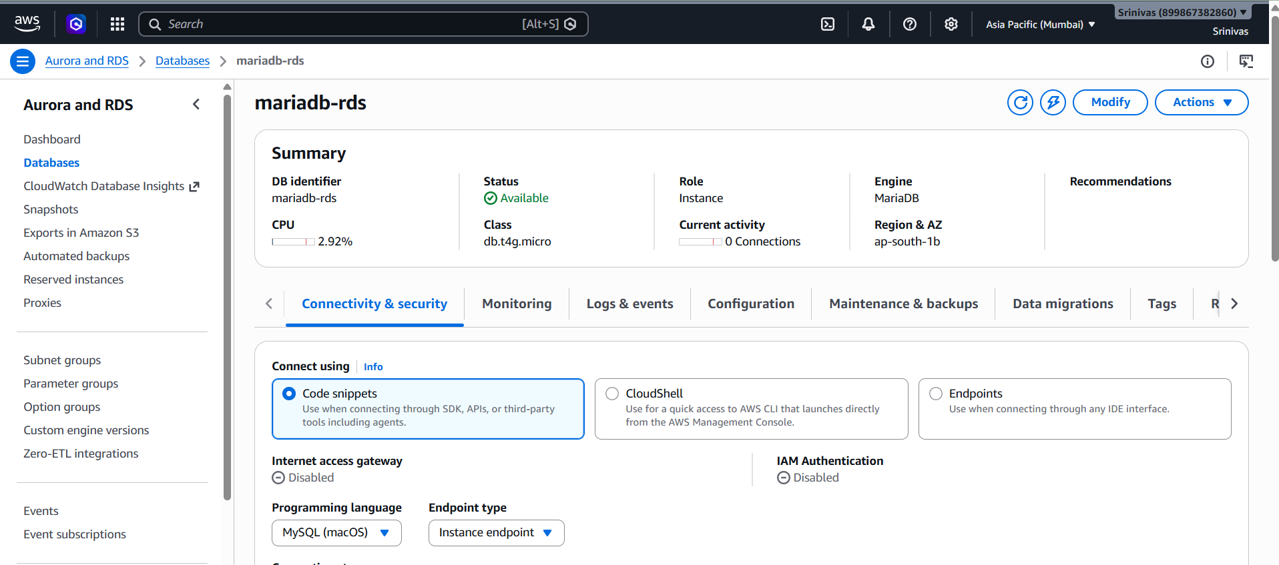
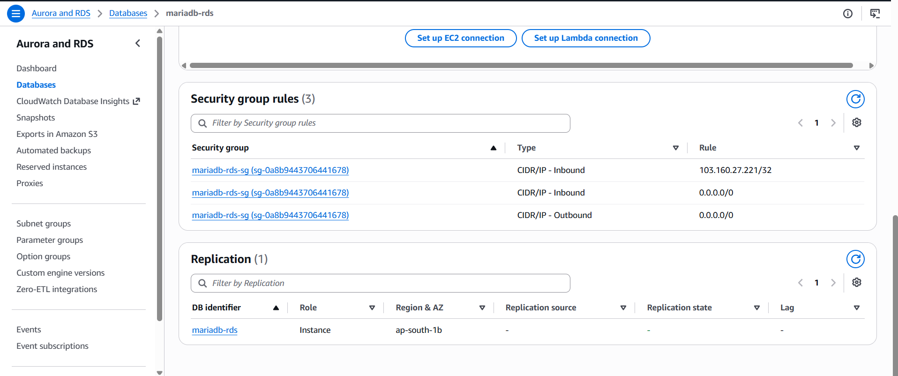

4. Migrate MariaDB EC2 to RDS
- Download certificate if required.
- Create database on RDS if needed.
- Import backup:
- mysql -h <endpoint> -u admin -p --ssl-ca=global-bundle.pem company < company_backup.sql
- Verify:
- USE company;
- SHOW TABLES;
- SELECT * FROM employees;
- Screenshot: data available in RDS.
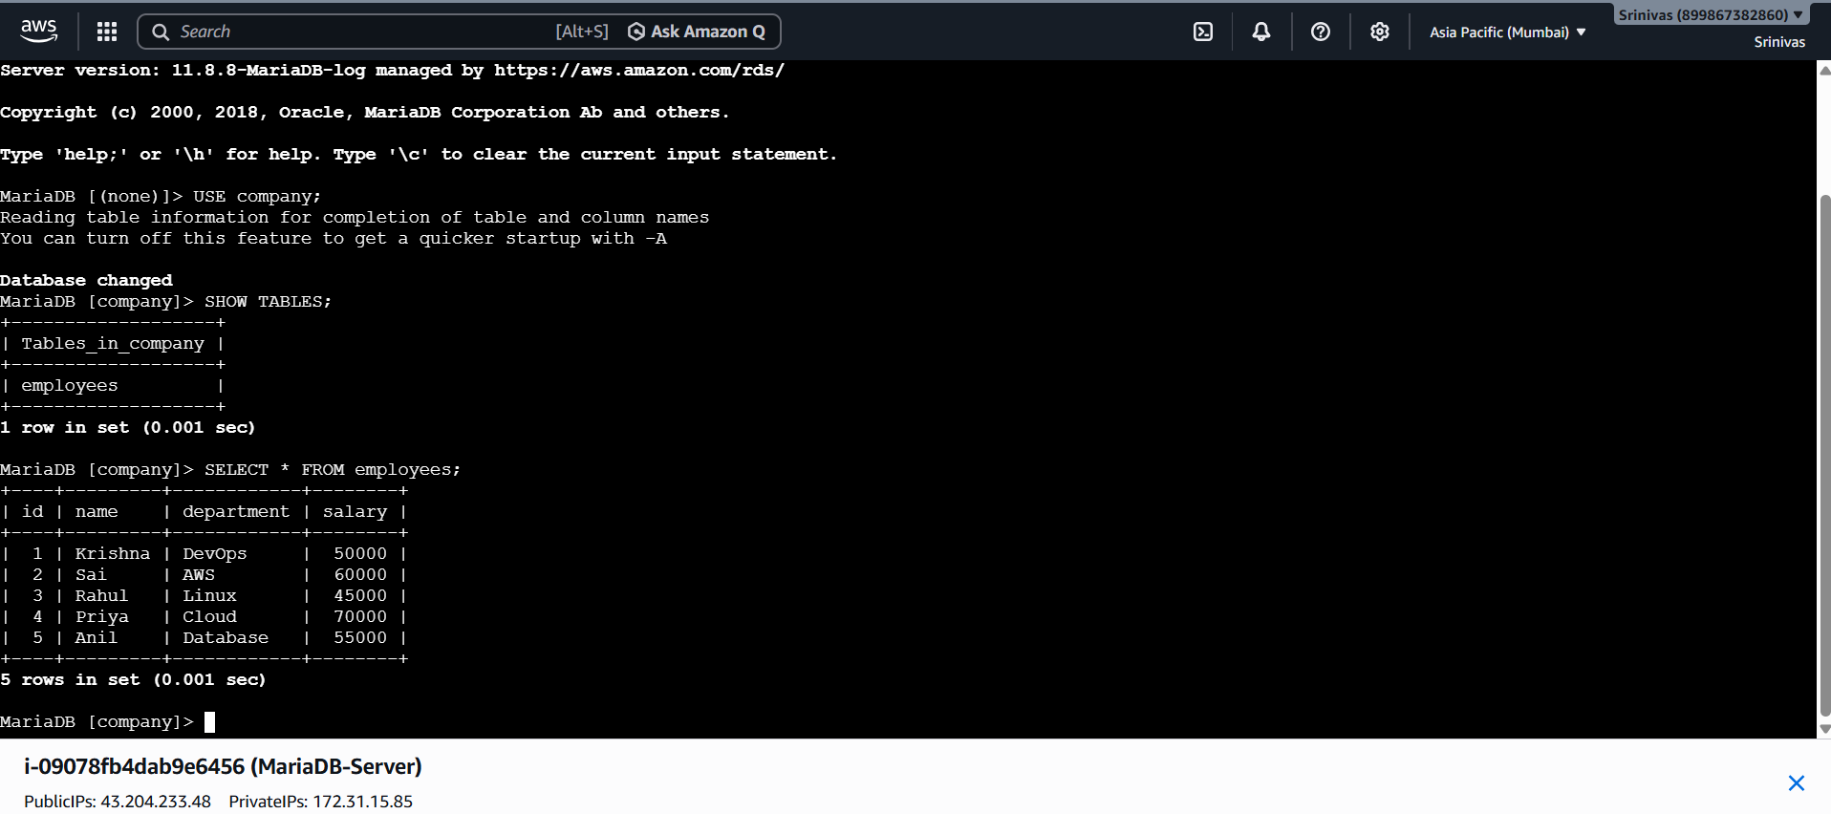

5. Install MySQL on EC2
- Install MySQL/MariaDB client.
- Verify using mysql --version.
- Screenshot: version output.
- 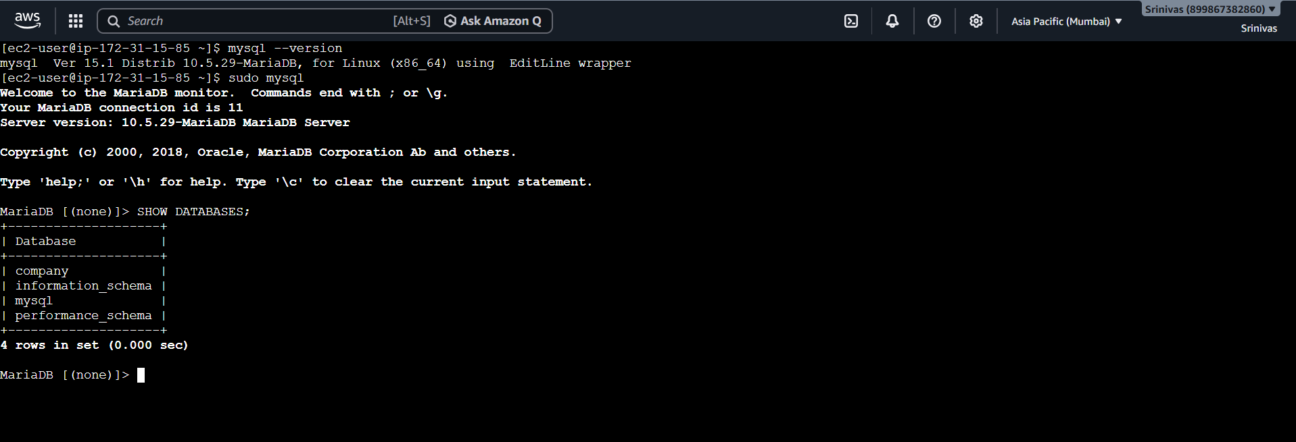

6. Launch MySQL RDS
- Create MySQL Community RDS instance.
- Wait until status is Available.
- Configure Security Group to allow EC2 access on port 3306.
- Screenshot: MySQL RDS Available.
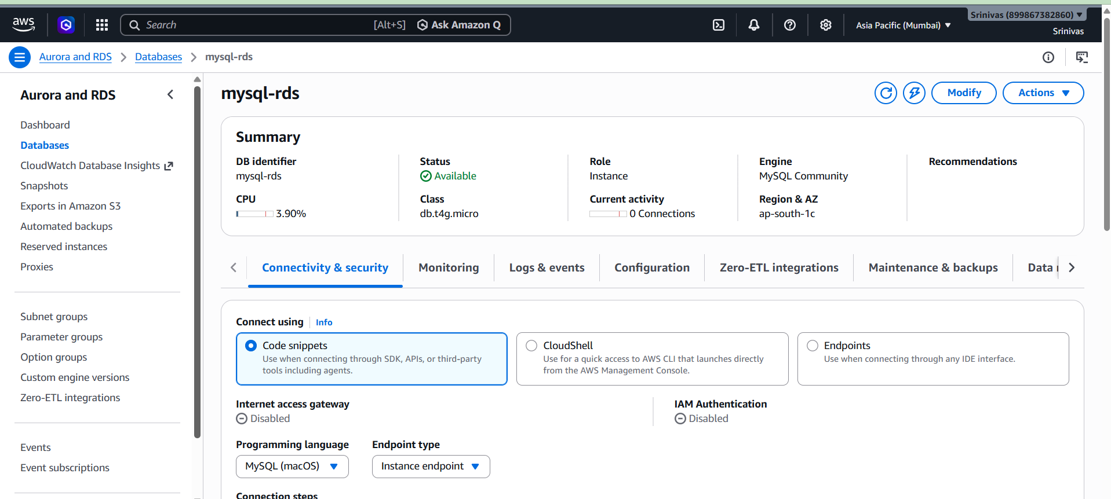
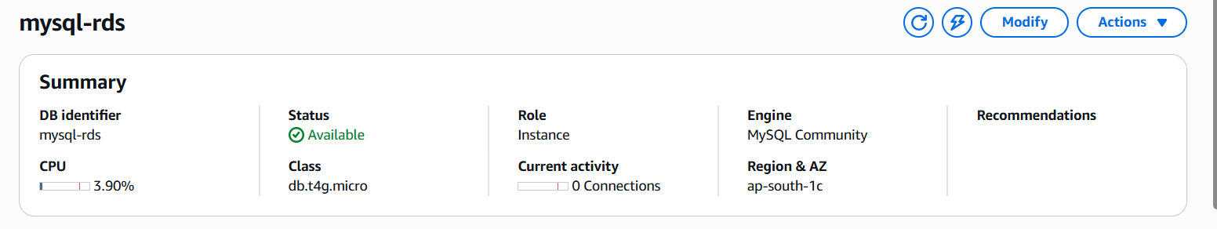
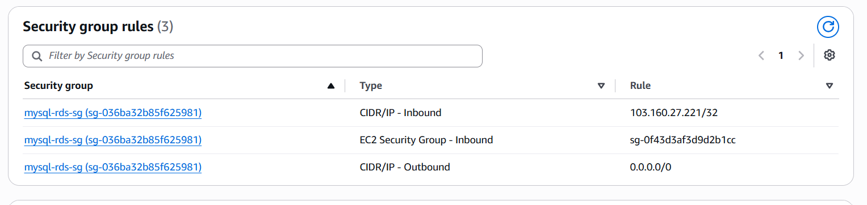

7. Migrate EC2 to MySQL RDS
- Connect to MySQL RDS:
- mysql -h <endpoint> -P 3306 -u admin -p --ssl-ca=./global-bundle.pem
- Import backup if required.
- Verify:
- USE company;
- SHOW TABLES;
- SELECT * FROM employees;
- Screenshot: migrated data.
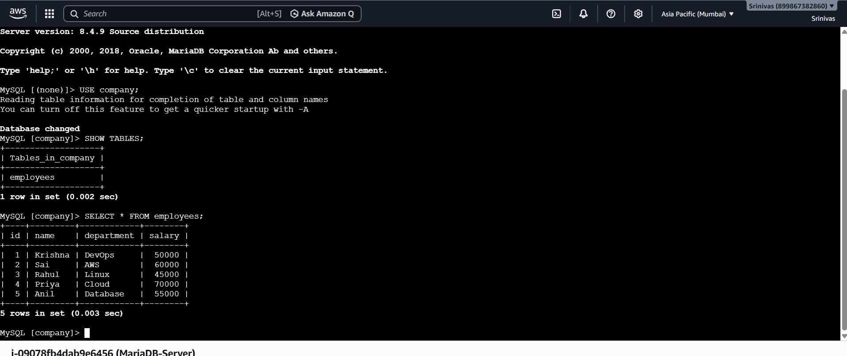

8. Configure Multi-AZ
- Open Modify DB instance.
- Attempt to enable Multi-AZ.
- Result: Option unavailable/greyed out due to Free/Lab account limitation.
- Screenshot: greyed-out Multi-AZ option.
- Note: Multi-AZ deployment could not be enabled because the AWS Free/Lab account does not support this feature for the current DB instance configuration.
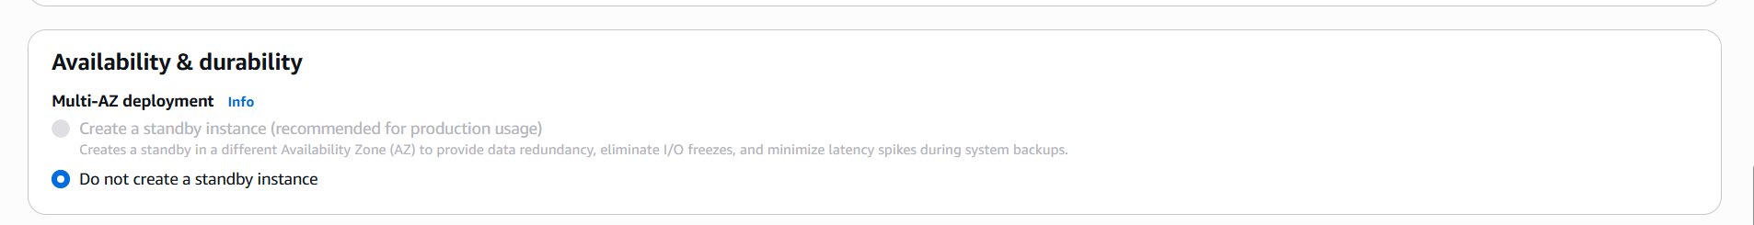

9. Backup and Restore
- Create manual snapshot: mysql-rds-backup.
- Screenshot: Snapshot created.
- Attempt Restore Snapshot.
- Result: Restore blocked because maximum RDS instances reached.
- Screenshot: AWS error message.
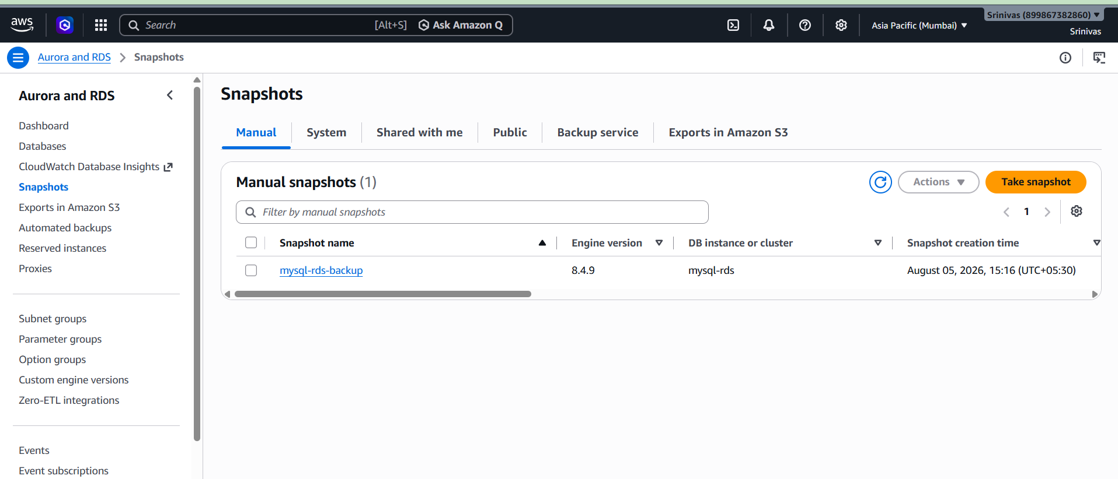
Note: A manual snapshot was created successfully. However, restoring the snapshot could not be completed because the AWS Free/Lab account had reached the maximum number of RDS instances allowed. The restore process was attempted but could not proceed due to the account limitation.
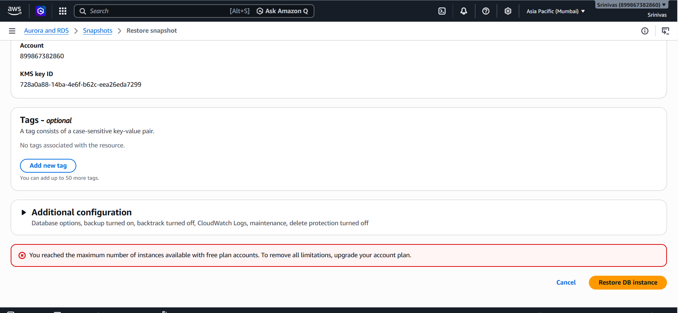

10. Create Read Replica
- Open Actions > Create read replica.
- Attempt replica creation.
- Result: Creation blocked because maximum RDS instances reached.
- Screenshot: AWS error message.
- Note: The Read Replica creation process was initiated successfully. However, the Read Replica could not be created because the AWS Free/Lab account had reached the maximum number of RDS instances allowed. The task was attempted, but AWS account limitations prevented completion.

- 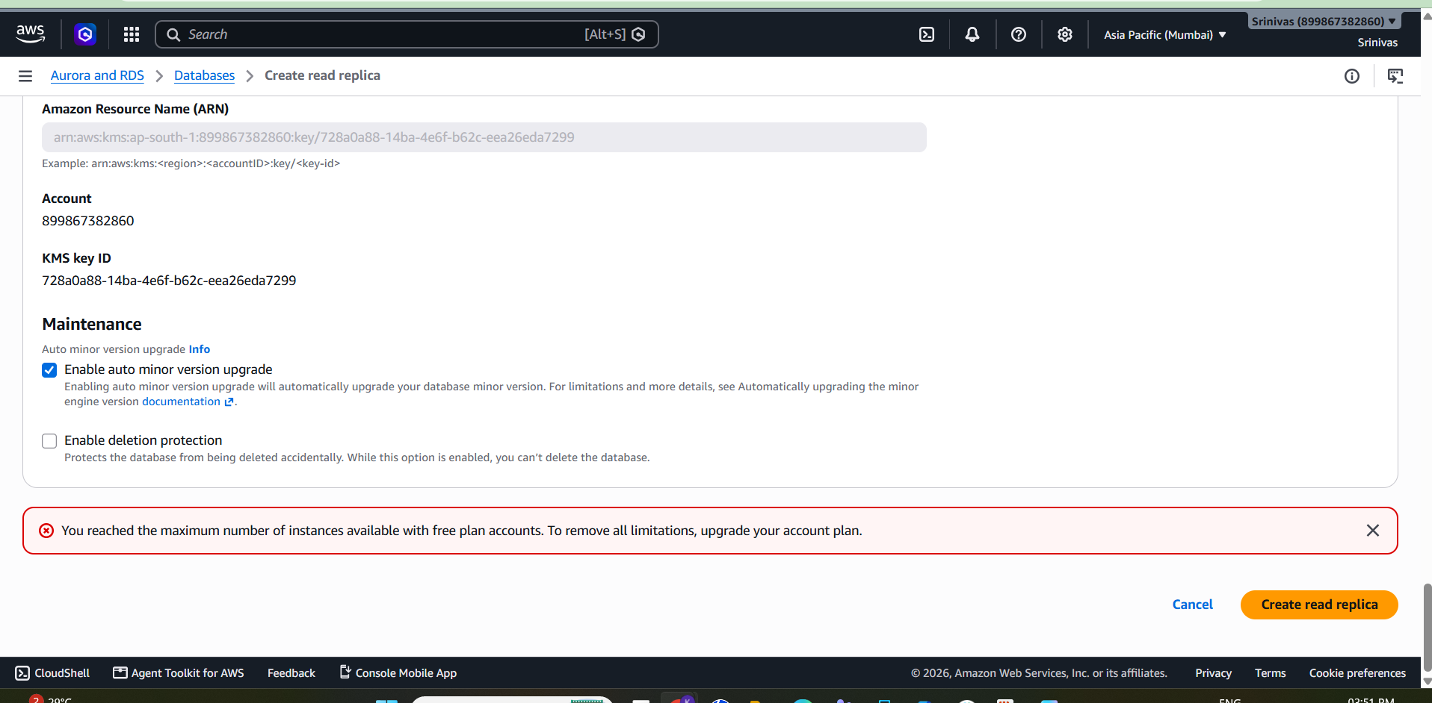

Conclusion
All required tasks were completed where permitted. Multi-AZ, Restore from Snapshot, and Read Replica creation could not be completed because the AWS Free/Lab account had service limitations (maximum RDS instances / restricted features). Relevant screenshots are attached as evidence.

